CRF ID: 107176 | Requested By: Praveen P | Developer: ANVITO C S,DILSON C D,VEENA VIJAYAN V
SR No.36551 | User Dept: ONLINE GOLD LOAN
Tech Lead: SABITHA C B | Testing Engineer: AKHIL VISHNU | Release Date: 22-02-2022
Project name: | CRF for an Option to update morning meeting minutes.
Brief description of Project | CRF for an Option to update morning meeting minutes.

UPLOAD MEETING MINUTES

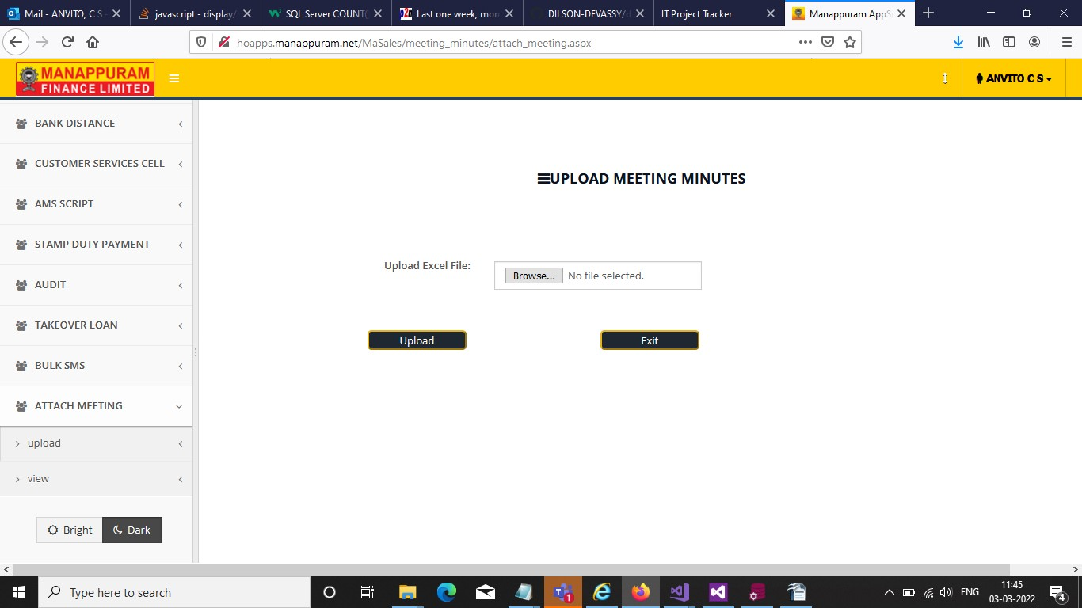

BROWSE ANY FILE

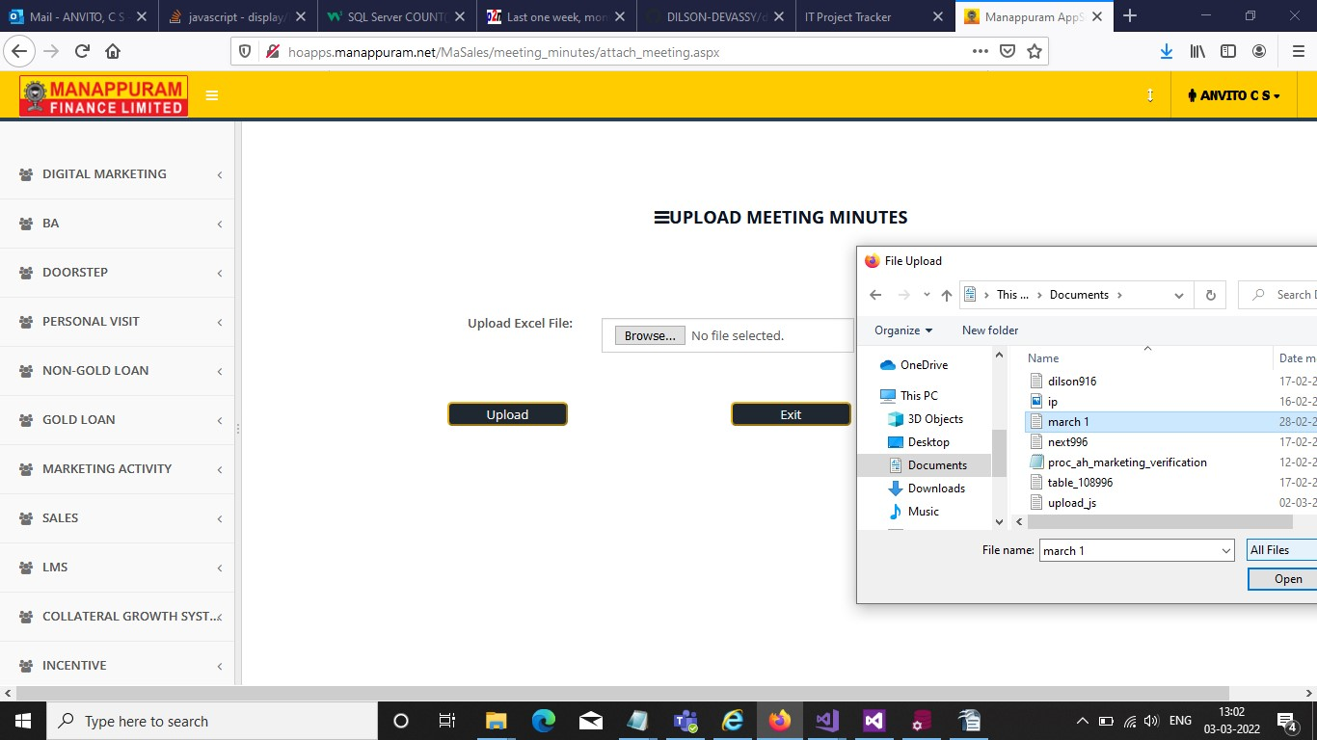

VIEW UPLOAD DOCUMENT

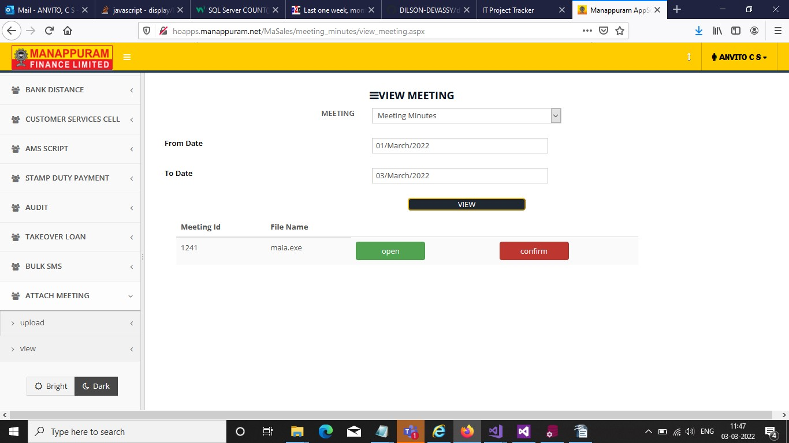

Modified database elements -
DB Element Type | DB Element Name | Change details | Reasons for the change
Tables: | Nil | Nil | Nil
Procedures: | proc_door_call_center  proc_hoapp_docupload | NIL | NIL
View: | Nil | Nil | Nil
Other Elements: | Nil | Nil | Nil

New Database Elements -
DB Element Type | DB Element Name | Reasons for bringing this new change
Tables: | tbl_attach_dataminutes  dms.tbl_attach_minutes | NIL
Procedures: | Nil | Nil
View: | Nil | Nil
Other Elements: | MEETING_ID | Sequence

Web Service level Modification
Service Type | Service Name | Change details | Reasons for the change
Tables: | Nil | Nil | Nil
Procedures: | Nil | Nil | Nil
View: | Nil | Nil | Nil

Application deployment details ( DC)
Parent Application Name | Domain Name | Application Server Details ( IP Details) | Folder Location
MaSales | hoapps.manappuram.net | 10.0.0.130,10.0.0.132(DC) | e:\sites\masales

Application deployment details ( DR)
Parent Application Name | Domain Name | Application Server Details ( IP Details) | Folder Location
MaSales | hoapps.manappuram.net | 10.10.3.104(DR) | e:\sites\masales

Infrastructural changes if any
Nil

Vendor level integrations if any
Nil

